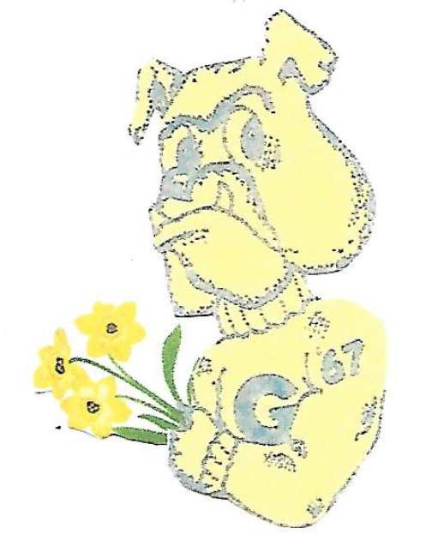
MARCH/APRIL 2023
Happy Spring! Another new season has arrived and with it we wish all GHHS alumni from the Class of ’67 & their families one of hope & happiness!

News this issue seems to be a little “short” for reporting, however, we hope you will enjoy reading what we were able to gather.

Fifteen Alums & six “significant others” did gather on February 21st at Harry’s Steakhouse in Independence for a casual dinner. The camaraderie & food were what was planned – a good time had by all. The photo below indicates those alumni in attendance: Terry Scott, George Majczenko, Ken Zach, Bill Williams, Doug Barto, Alan Novello, Erin Barto (Doug’s daughter), Dan Mihalik, Tom Hola, Audrey Sopko, Sharon Travagliante Weitzman, Linda Wike Calkins, Mike Heba, Tom Pavlinsky, Karen Parhamovich Felon and Jan Wroblewski Hola.

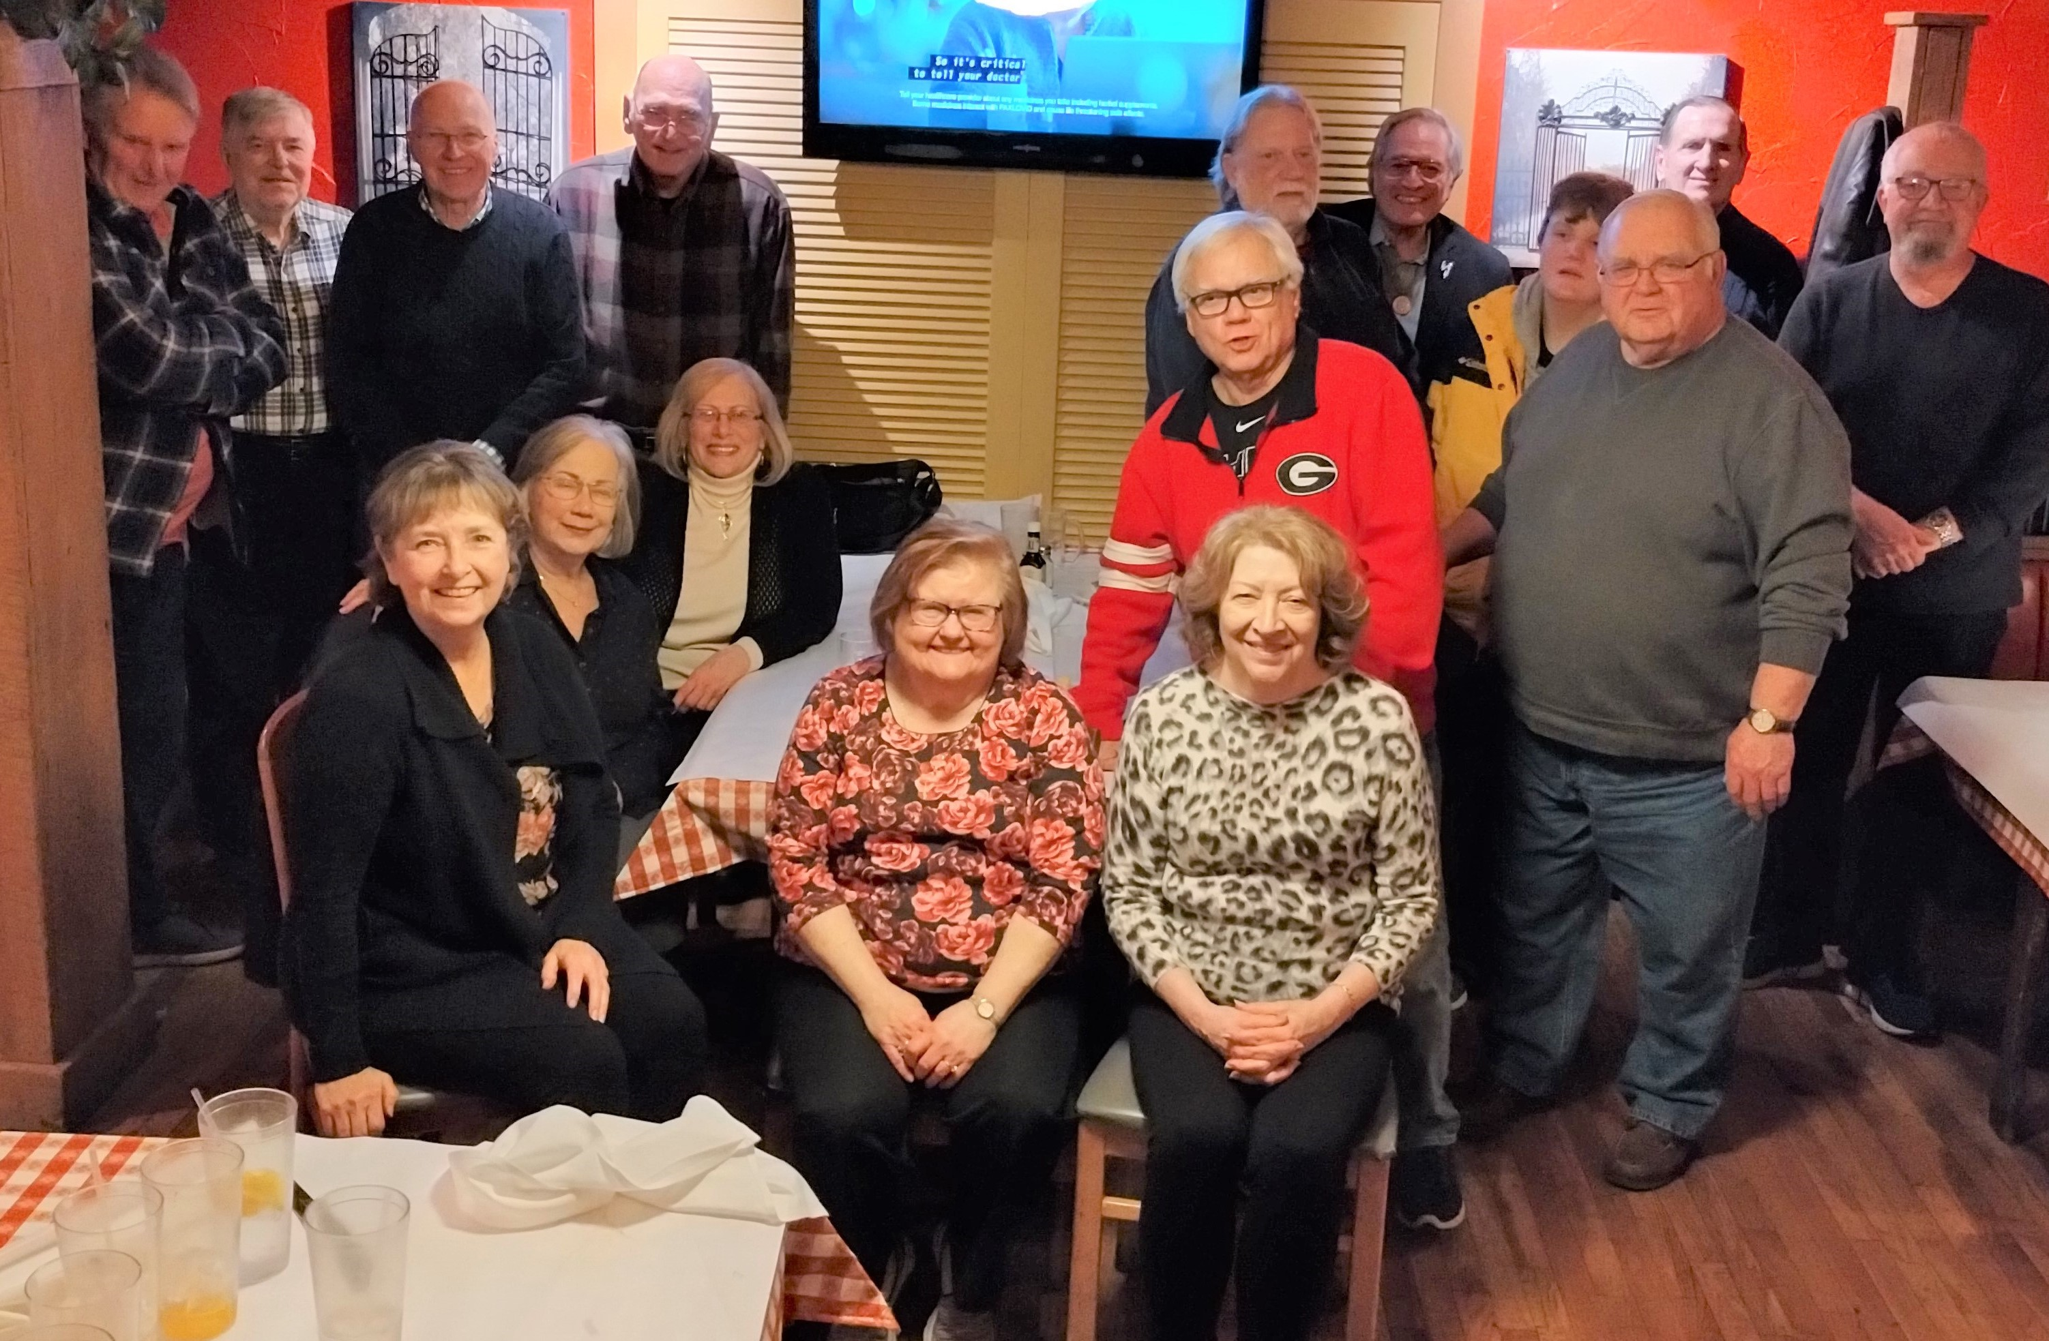
Join us next time!



Our Traveling Alumni – Karen Soika Palker left home on March 1st to travel to Myrtle Beach, SC, to visit family, and then pushed onward to Florida where she spent some time with Joe & Pamela Poveroni Conrad, who winter there.

Sharon Travagliante Weitzman with husband, Skip, were in Chicago on March 17th for St. Patrick’s Day. Wonder if they viewed the parade?

Gail Russler Meyer spent March 23 – April 7th visiting Japan, and what a wonderful experience it was! Her niece, Deanna, accompanied her and told Gail she wants to move there! Primary objective was to view the thousands of cherry blossoms in bloom at that time throughout the country. Mother Nature did not disappoint! And, there was so much more to see & do!

April 7th found Amy Roman Kostka & husband, Bill, home from cruising the Caribbean aboard Disney Cruise Lines. Fun times!

Audrey Sopko was in Jacksonville, NC, April 6-9th for the wedding of her niece’s daughter. It was a military wedding with the groom being a Marine who had been stationed at Camp Lejune.

Tom & Jan Wroblewski Hola plan to be in Florida April 22-29, for the 60th wedding celebration of her sister & brother-in-law, and,

Helen Steblinski Cejer will be traveling to the Bahamas on April 24th and staying at the Atlantis. Her daughter was married there & every year they like to celebrate each anniversary where it all began!

Kudos are extended to Gloria Radziewicz Holloway & husband, Brian, upon becoming great-grandparents to a baby boy weighing 8lbs. & 11oz.in March. Mom & baby are doing well.

Thinking of Marlene Krzywkowski Sooy who had heart surgery at the Cleveland Clinic on March 7th & is recovering nicely; Dusty Bowling who had to have a second heart/lung related surgery in March but is also recuperating & feeling great, and to Audrey Sopko & Dusty Bowling whose daughter, Keleigh, returned to the Cleveland Clinic for a 19 day stay due to her medical issues.

Condolences to Gerald Kuntz & family upon the passing of his brother, Michael, 76, on March 29, 2023. We are certainly thinking of you, Gerald, and send our sympathies.

We are thinking of all of you!

Newsy Reflections & Tidbits: The “Lady Bulldogs” celebrated St. Patrick’s Day with lunch at 12:30pm at Mavis Winkle’s in Twinsburg on March 25th. One suggestion was to remember to wear green!! Those who participated were: Diane Marzano Mauser, Linda Sindelar Kavaras, Jan Wroblewski Hola, Sharon Travagliante Weitzman, Audrey Sopko, Linda Wike Calkins, Karen Soika Palker, Nancy Levis Knowlton, & Kathy Schneider Nowack.

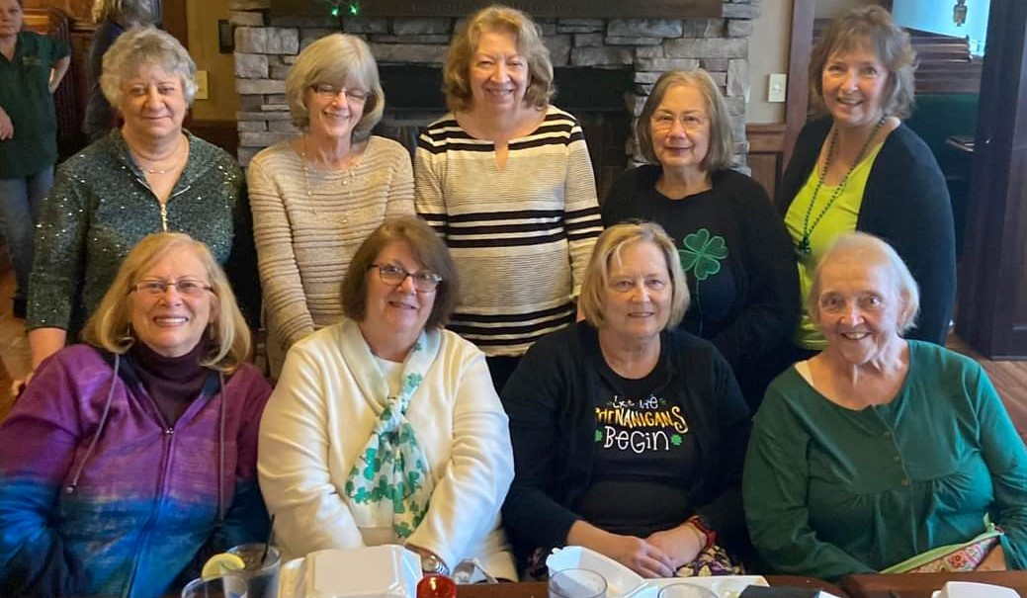

The ladies will be celebrating Cinco de Mayo (a day late) on May 6th, 12:30pm, at Cosumel’s in Independence. RSVP to Audrey Sopko through the group’s FB page, or by email at , or by text to 440-292-5088, if you would like to attend.

☼ ☼ ☼ ☼ ☼ ☼ ☼ ☼ ☼ ☼ ☼ ☼ ☼ ☼ ☼☼ ☼ ☼ ☼ ☼ ☼ ☼ ☼ ☼ ☼ ☼ ☼ ☼ ☼ ☼

Not So Long Ago, Was It?

Dr. Louis Zagar recently brought to our attention a photograph he found from what he believes was taken at a 1975 GHHS All School Assembly. It sparked a few memories & he wanted to share with them with us. At that time Louie was beginning his music teaching/conducting career at Midpark High School in Berea. He remembers contacting Mr. Stella about bringing the concert band he conducted to GHHS for an all-school music assembly. It would be the first time he was back at the high school since his graduation and it was quite a trip! Louie got to chat with several of his former teachers who were still teaching there.
In the photo, the person at the piano, Tim Corrao, who was legally blind & graduated from GHHS a few years after us, was, and still is, a very talented pianist and composer. He wrote a beautiful ballad called “The Ballerina” and the assistant Midpark choir director, Paul Wilbur, a tenor, sang the tune with Louis’ full band (75 students) behind him. Tim went on to study at the Cleveland Institute of Music in composition and piano and later taught at the university level in West Virginia. His older brother, Chris (now deceased) was a good buddy of Louis (it was a love-hate relationship!) and was also a fellow clarinet player in the marching band who drove Louis around in his off-white AMC Rambler, complete with “WHK, Color Channel 14, Color Radio” blaring through the dash board speaker.

Later the following year, Louis’ band commissioned a piece from Tim titled “The MCB March” and they premiered it in 1976. To quote Louis, “Ah…the good times bringing back good memories! And YES…I still have all my hair....thank you DAD!”

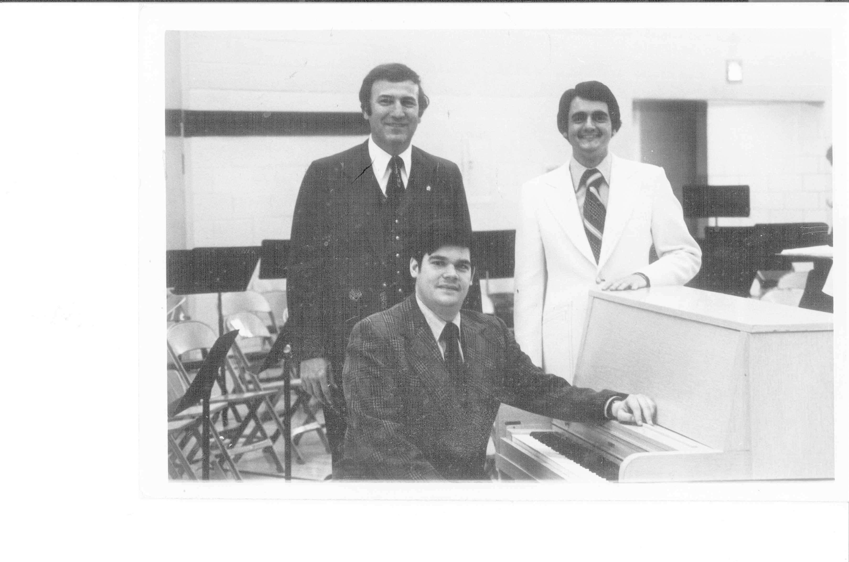
******************************************
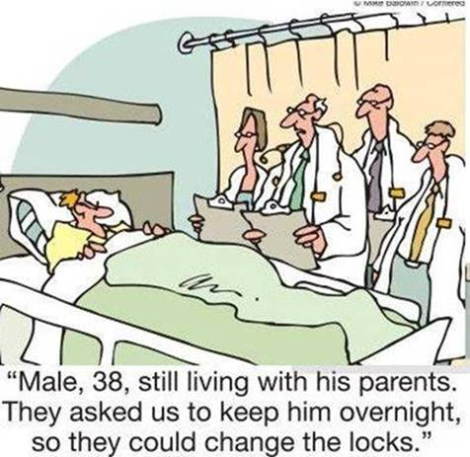
Here are a few chuckles from Ken Zielaskiewicz:



And a few more from Linda Reed Strauss:



And that’s about all the news for this issue!

Till next time, Go Bulldogs!

Your loyal editor,
Gail Russler Meyer

