
MAY/JUNE 2023

Summer is fast approaching, yet May & June seem to be the time where there is a flurry of activities and celebrations related to weddings, graduations, BBQs, and, in Ohio, just finally being able to get outdoors. We wish all of our alumni and their families a wonderful beginning to the coming summer months!

As a tidbit to this time of year, May & June seem to be months that have national celebrations. May 14th was Mothers’ Day and June 18 was Fathers’ Day. Hopefully, all of you moms & dads, whether it be to 2 legged or 4 legged “children” had a wonderful day with family and/or friends.

Did you know that historically May & June are months that observed, honored or acknowledged the creation of select individuals or organizations for their contributions to our nation? Such as:

- The Formation of WAAC, or the Women’s Army Auxiliary Corps, was established on May 15, 1942. Prior to the start of WWII, women were generally only allowed on the battlefield as nurses, volunteers, communications specialists or as dieticians. Though they served with the Army, they had no official status and had to pay for their own food & lodging with no disability benefits or pensions when they returned home. Congresswoman Edith Nourse Rogers knew of this situation & in 1941 met with General George C. Marshall, the Army’s Chief of Staff & told him of her plan to introduce a bill to create a women’s corps that was separate from the Nurse Corps. It wasn’t until the Japanese attack on Pearl Harbor that the bill was seriously considered. After significant debate, the bill passed, although compromised from its intended structure of equal pay, pension, & disability benefits. President Franklin Rosevelt signed it into law on May 15, 1942. He set the recruitment goal as 25,000 which was met by November, and then increased to 150,000. Every woman recruited would “free a man for combat”. The first batch of officer recruits were an average of 25 years old, most had attended college and worked in an office or as a teacher. One in five enlisted because a male family member was serving & they wanted to help him get home faster. The success of the WAAC led to similar auxiliaries – WAC, the WAVES, SPARS, and the US Marine Corps Women’s Reserve.

- On October 1, 1961, the 87th Congress requested President John F. Kennedy establish May 15 as a day to honor the nation’s peace officers. One year later, President Kennedy signed the bill into law. The bill proclaimed that May 15 would be celebrated as Peace Officers Memorial Day, and the week during which May 15 occurred would be Police Week. This act said it was to pay tribute to the law enforcement officers who have made the ultimate sacrifice for our country and to voice our appreciation for all those who currently serve on the front lines of the battle against crime. In 1994, Bill Clinton ordered that US flags be flown at half-staff on that day in recognition of the observances. Americans around the country observe the day in their own communities, generally sponsored by the National Fraternal Order of Police & overseen by the Fraternal Order of Police Memorial Committees. Today, there are currently more than 800,000 law enforcement officers serving in 19,000 different law enforcement agencies.

- And one that we now can relate to, and appreciate, is the Older Americans Month in May. On May 1, 1963, the US observed its first Senior Citizens Month, later renamed Older Americans Month. Since its inception, it has been a time to raise awareness of issues facing older Americans as well as honor their contributions to our nation. Prior to 1963, the U.S. created some programs aimed at older Americans, such as the Civil Service Retirement Act (1920), the Social Security Act (1935) and the Railroad Retirement Act (1937). Both the Special Staff on Aging and the Federal Council on Aging were established in 1956.. The White House hosted its first Conference on Aging in 1961 and Congress established a permanent Commission on Aging in 1962. President Kennedy met with the National Council of Senior Citizens in 1963 and developed a plan to establish Senior Citizens Month. He issued an official proclamation on April 18, designating May 1963 as Senior Citizens Month. He urged Americans to use this as a time to raise awareness of the problems they faced & search for new opportunities & services to best address their needs. Two years later, President Lyndon B. Johnson signed the Older Americans Act into Law on July 14, 1965. It formally established May as Older Americans Month & took further steps to help America’s seniors, as it created the Department of Health, Education & Welfare’s Administration on Aging, which would oversee grant programs and other government activities for older Americans. It also led to the addition of Medicare. Every president since Johnson has issued a formal proclamation for Older Americans Month in May. Local groups stage events, fairs and fundraisers celebrating older Americans.



Our Traveling Alumni were: Kathy McCullough Scott who visited Galveston Beach with hubby, Rick, in early April;

Rhea Jones Ashmore who traveled and viewed Egypt’s many magnificent wonders in May;

Audrey Sopko who made a visit in May to Ripley, NY, and stayed in a cabin with a friend;

Doug Day with wife, Jackie, spent one month in March in Punta Gorda, FL, and now just returned from 10 days in Wyoming and a trip to Columbus, OH;

Dusty Bowling with fiancée, Norma, boarded a cruise ship in Vancouver, British Columbia on June 9th to see some of Alaska. On June 10th at 5 a.m., Dusty saw his first whale! They return June 20th. The picture was taken in Juneau. And,

Linda Maciaszek Fauble who is traveling to Michigan late June for a visit to her daughter and especially her granddaughter. Her granddaughter, Alyssa, 16, began her theater journey six years ago at the Warren Civic Theater in Michigan. She started in the ensemble of the musical “Seussical” to playing Auntie Em in “The Wizard of Oz”. This year she performed in her high school musical, “Shrek the Musical”. Linda’s trip to Michigan is to see Alyssa as Cruella DeVil in “Disney’s Descendants” in a neighborhood theatre. For Alyssa’s senior year, she plans on auditioning for the high school musical scheduled in February, 2024. To say the least, Linda is extremely proud of this girl!

Happy Trails, Everyone!

Kudos to: Audrey Sopko whose great niece, 14 year old Reagan, was named Defensive Player of the Year for the McKinney District Ice Hockey Club in McKinney, Texas. And yes, it is a high school boys’ varsity team!

Dianne Whiteside Predovic who became a great-grandmother in April;
Candice Coneglio Frantz whose grandson, Chris, just graduated from high school and is now heading to college, and,
Doug Day & wife, Jackie, who made that 10-day trip to Wyoming to visit their 4-month old granddaughter, Phoenix, who was born in February. They also became grandparents again in May when Indiana (Indy) Day, was born to their son & daughter-in-law in Ohio;

To Barbara Filipski Bunsey who on May 3rd was once again named to the Early American Life Magazine Directory of Traditional Crafts. This honor is bestowed to a handful of artisans who work in traditional media, styles & crafts. Barb has been a member of the Directory since 2004.

Randy Stakes with wife, Kathy, celebrated their 52nd wedding anniversary on June 19th, as did Karen Kuderna Kudley with husband, Andy on the same day. And,

Connie Tortorici Smolko & husband, Tom, upon the marriage of their son, Tom, to Britni. They were married at Sunset Beach, Treasure Island, FL, and Connie says the weather & ceremony were beautiful for this small wedding.
Congratulations All!!

Thinking of: Peggy Terry Berteau, who fell in early May on the patio of their home, landed on her back and broke her arm. She had surgery and was pretty sore. She also now had to do everything left handed and temporarily can’t even spell with her left hand! We hope she is quickly recuperating!

***************************************************

Other Tidbits: Mary Chadwick has been having a problem with a medical issue called, Lymphedema. She reached out to us asking if anyone of our cancer “partners” might know anything about this, as she would appreciate any help anyone could give her about this disease. Mary’s email address is chadzacsyd@gmail.com.

And, The Lady Bulldogs celebrated Cinco de Mayo a day late on May 6th, at Cosumel’s in Independence. Those who participated were Linda Maciaszek Fauble, Amy Roman Kostka, Nancy Levis Knowlton, Audrey Sopko, Karen Soika Palker, Ruth Mendala Thompson, Diana Trego, Linda Wike Calkins, Helen Steblinski Cejer and Kathy Schneider Nowack.

Their next luncheon will be June 24th, 12:30pm, at Danny Boy’s in Broadview Heights. If you would like to attend, contact Audrey Sopko via email (asopko@sbcglobal.net or by text (440-292-5088). Come & join the camaraderie!

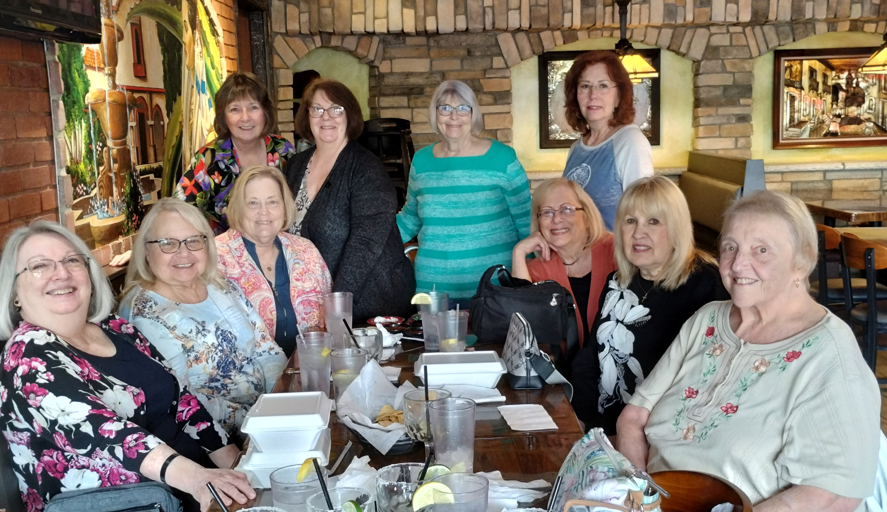


On April 29th, a separate email was sent to alumni including information concerning the Chris H. Mather Memorial Tournament on June 9, 2023. Chris was a former faculty member of GHHS and another former faculty member, Dennis Blue & his wife, Joyce, asked if we could spread the word to the Class of ’67 in case any of us would like to participate. Joyce has since reached out to us indicating that there had been an overwhelming response to the event. She thanks us for spreading the word!

*******************************

And thanks to Nico Bujak, here are a few little pics to keep us smiling!



And that, folks, is this newsletter! Please keep us informed of any new contact info for you, and if you have some news to share with us, please contact me at (grdmohio@gmail.com). We love Alumni news! Until our next issue, GO BULLDOGS!

Your energetic editor,

Gail Russler Meyer

